Part 1:
You will be studying and analyzing two companies' dividend policies. Find a company that has a dividend yield under 1% and a company that has a dividend yield of 4% or greater. Summarize your findings for the 3 issues listed below.
1) Review the last 3 years of dividend payments - note any increases, decreases, stock splits, stock dividends, and news about the company that affected dividend payments
2) Calculate the companies' expected stock price using the Dividend Discount Model - you will need to calculate g (growth) and make other assumptions
3) Assess the prospects for the companies to continue or increase their dividends in the future (concentrate on future cash flows)
Company with dividend yield under 1%
Oracle Corp. (ORCL:AR)
Background and Review (sub-question 1):
Sector: Technology
Industry: Software
Sub-Industry: Enterprise Software/Service
Oracle Corporation supplies software for enterprise information management. The Company offers databases and relational servers, application development and decision support tools, and enterprise business applications. Oracle's software runs on network computers, personal digital assistants, set-top devices, PCs, workstations, minicomputers, mainframes, and massively parallel computers.
Oracle Corp. Stock Dividend Data
Annual Payout | 0.24
Dividend Yield | 0.69%
Payout Frequency | Quarterly

History of Dividend Payments
Oracle is one of the companies’ with dividend yield of less than 1%. While in 2009 dividend yield was 0%, it is reported to be 0.68%, 0.74%, and 0.73% in the years 2010, 2011, and 2012, respectively. Dividend pay has fractionally increased from $0.05 to $0.06 in 2011. Current dividend yield is 0.7% in 2013 quarter.
Special Dividend Payments - Accelerated Distribution of Cash
In December 2012, Oracle announced it would pre-pay $867 million worth of dividends, which were otherwise due in 2013. The government has proposed higher taxes on dividends and capital gains, which are taxed at 15 per cent, starting year 2013. So to help company’s shareholders offset some of the risks of higher taxes forced by the fiscal cliff, the company announced special dividend payments. Company paid three of 2013 year’s dividend early in December 2012. Last dividend paid was $0.18 instead of $0.06.
Common Stock Repurchase Policy
The company’s Stock Repurchase policy discusses the following -
- Stock repurchase authorization does not have an expiration date.
- Repurchase activity depend on factors such as –
  - Company’s working capital needs.
  - Cash requirements for acquisitions and dividend repayments.
  - Debt & Repayment obligations.
  - Stock prices and, economic and market conditions.
- Stock repurchases may be effected from time to time through open market purchases or pursuant to a Rule 10b5-1 plan.
Common Stock Repurchase History
- December 20, 2011: Company announced, Board of Directors approved expansion of stock repurchase program by an additional $5.0 billion.
- June 18, 2012: Company announced a further approved expansion by an additional $10.0 billion.
- May 31, 2012: Approximately $3.1 billion remained available for stock repurchases
- June 2012: Additional amount authorized.
- Company repurchased:
  - Fiscal 2012 - 207.3 million shares for $6.0 billion,
  - Fiscal 2011 - 40.4 million shares for $1.2 billion
  - Fiscal 2010 - 43.3 million shares for $1.0 billion
Cash Dividends
Fiscal 2012: Company declared and paid cash dividends of $0.24 per share that totaled $1.2 billion.
Company’s Stock Options
- Stock-based compensation program is a key component of the compensation package.
- Stock options granted only to employees and controlled number of stock options.
- Options generally have a 10 year exercise period, have exercise prices higher than the current market price of company’s common stock.
- At May 31, 2012, 28.0% of outstanding stock options had exercise prices in excess of the current market price.
- A separate Plan Committee, which is an executive officer committee, approves individual stock option grants of up to 100,000 shares to non-executive officers and employees
Expected Stock Price (sub-question 2):
Using the Dividend Discount Model, (at 12/12/2012 when the last dividend payment was made) -
- P0 = $34
- D0 = $0.18
- R = Return on equity = 24.66%
- D1 = D0 * (1 + g)
- P0 = D1 / (r - g)
- 34 = 0.18 * (1 + g) / (.2466 - g)
- g = 23.80%
- P1 = D0* (1 + g)(1 + g) / (r - g)
- Expected stock price = $32.25
Oracle’s stock’s estimated price at the end of 2nd quarter of year 2013 is $32.25

Future Assessment (sub-question 3):
It is observed that the company is holding huge free cash flow (FCF). It signals that Oracle Company has reserves to pay debt, pay dividends, buyback stock and facilitate the growth of business all important undertakings from an investor's perspective. A sharp change in Free Cash Flows is seen from 1.126 billion to 583 million is seen due to accelerated dividend distribution. On many occasions company opted for 2-to-1 and 3-to-2 common stock split. It can be a strategic decision in order to boost its share price. As seen from the chart below sharp change in price per share, apart from company’s good performance, can be because of stock split.
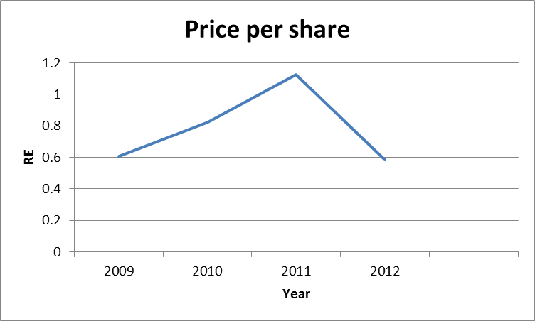 | 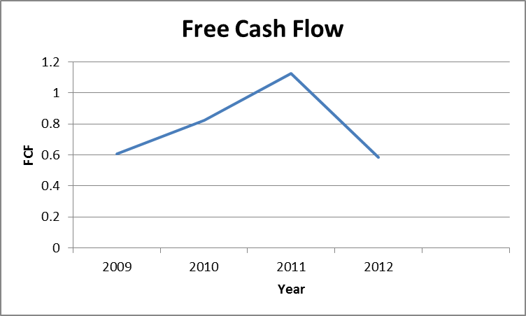
Based on Oracle’s recent performance highlight, the following facts can be noted.
- The company reported better-than-expected fiscal second quarter results last month.
- Positive earnings ~60 cents per share
- Revenue increased 3.4% year-over-year to $9.11 billion, primarily driven by strong new software license sales.
- Operating margin expanded 190 basis points (“bps”)
- Dividend yield of 0.7%
Based on the above observations, the following analysis can be presented.
- Relatively stable cash flow.
- Improved liquidity position.
- Stringent cost controls.
- Reduced operating expenses.
- Steady dividend yield.
The above factors make the stock much more attractive for investors even if dividend yield is lower than 1 percent.

APPENDIX FOR PART 1 -
APPENDIX FOR ORACLE CORP.

STOCK SPLITS
Effective Date | Split Amount
October 12, 2000 | 2 for 1
January 18, 2000 | 2 for 1
February 26, 1999 | 3 for 2
August 15, 1997 | 3 for 2
April 16, 1996 | 3 for 2
February 22, 1995 | 3 for 2
November 8, 1993 | 2 for 1
June 16, 1989 | 2 for 1
December 21, 1987 | 2 for 1
March 9, 1987 | 2 for 1

Data provided by Capital IQ, except where noted.
Valuation Measures

Market Cap (intraday)⁵: | 164.40B
Enterprise Value (Jan 17, 2013)³: | 150.06B
Trailing P/E (ttm, intraday): | 16.33
Forward P/E (fye May 31, 2014)¹: | 11.77
PEG Ratio (5 yr expected)¹: | 1.07
Price/Sales (ttm): | 4.40
Price/Book (mrq): | 3.83
Enterprise Value/Revenue (ttm)³: | 4.03
Enterprise Value/EBITDA (ttm)⁶: | 8.67

Financial Highlights

Fiscal Year
Fiscal Year Ends: | May 30
Most Recent Quarter (mrq): | Nov 30, 2012

Profitability
Profit Margin (ttm): | 28.38%
Operating Margin (ttm): | 38.49%

Management Effectiveness
Return on Assets (ttm): | 11.74%
Return on Equity (ttm): | 24.66%

Income Statement
Revenue (ttm): | 37.23B
Revenue Per Share (ttm): | 7.59
Qtrly Revenue Growth (yoy): | 3.40%
Gross Profit (ttm): | 29.26B
EBITDA (ttm)⁶: | 17.30B
Net Income Avl to Common (ttm): | 10.56B
Diluted EPS (ttm): | 2.13
Qtrly Earnings Growth (yoy): | 17.70%

Balance Sheet
Total Cash (mrq): | 33.70B
Total Cash Per Share (mrq): | 7.12
Total Debt (mrq): | 19.76B
Total Debt/Equity (mrq): | 45.51
Current Ratio (mrq): | 3.33
Book Value Per Share (mrq): | 9.05

Cash Flow Statement
Operating Cash Flow (ttm): | 13.53B
Levered Free Cash Flow (ttm): | 11.55B

Trading Information

Stock Price History
Beta: | 1.50
52-Week Change³: | 21.29%
S&P500 52-Week Change³: | 12.03%
52-Week High (Jan 14, 2013)³: | 35.00
52-Week Low (May 18, 2012)³: | 25.33
50-Day Moving Average³: | 33.27
200-Day Moving Average³: | 31.58

Share Statistics
Avg Vol (3 month)³: | 21,679,100
Avg Vol (10 day)³: | 16,470,000
Shares Outstanding⁵: | 4.73B
Float: | 3.55B
% Held by Insiders¹: | 23.00%
% Held by Institutions¹: | 60.40%
Shares Short (as of Dec 31, 2012)³: | 22.02M
Short Ratio (as of Dec 31, 2012)³: | 0.90
Short % of Float (as of Dec 31, 2012)³: | 0.60%
Shares Short (prior month)³: | 30.25M

Dividends & Splits
Forward Annual Dividend Rate⁴: | 0.24
Forward Annual Dividend Yield⁴: | 0.70%
Trailing Annual Dividend Yield³: | 0.36
Trailing Annual Dividend Yield³: | 1.00%
5 Year Average Dividend Yield⁴: | N/A
Payout Ratio⁴: | 11.00%
Dividend Date³: | Dec 20, 2012
Ex-Dividend Date⁴: | Dec 12, 2012
Last Split Factor (new per old)²: | 2:1
Last Split Date³: | Oct 13, 2000

Oracle Dividend History -
Ex/Eff Date | Type | Cash Amount | Declaration Date | Record Date | Payment Date
12/12/2012 | Cash | 0.18 | 12/3/2012 | 12/14/2012 | 12/21/2012
10/10/2012 | Cash | 0.06 | 9/19/2012 | 10/12/2012 | 11/2/2012
7/11/2012 | Cash | 0.06 | 6/18/2012 | 7/13/2012 | 8/3/2012
4/9/2012 | Cash | 0.06 | 3/19/2012 | 4/11/2012 | 5/2/2012
1/9/2012 | Cash | 0.06 | 12/19/2011 | 1/11/2012 | 2/1/2012
10/7/2011 | Cash | 0.06 | 9/20/2011 | 10/12/2011 | 11/2/2011
7/11/2011 | Cash | 0.06 | 6/22/2011 | 7/13/2011 | 8/3/2011
4/11/2011 | Cash | 0.06 | 3/22/2011 | 4/13/2011 | 5/4/2011
1/14/2011 | Cash | 0.05 | 12/15/2010 | 1/19/2011 | 2/9/2011
10/4/2010 | Cash | 0.05 | 9/15/2010 | 10/6/2010 | 11/3/2010
7/12/2010 | Cash | 0.05 | 6/23/2010 | 7/14/2010 | 8/4/2010
4/12/2010 | Cash | 0.05 | 3/23/2010 | 4/14/2010 | 5/5/2010
1/14/2010 | Cash | 0.05 | 12/16/2009 | 1/19/2010 | 2/9/2010
10/9/2009 | Cash | 0.05 | 9/16/2009 | 10/14/2009 | 11/4/2009
7/13/2009 | Cash | 0.05 | 6/22/2009 | 7/15/2009 | 8/13/2009
4/6/2009 | Cash | 0.05 | 3/17/2009 | 4/8/2009 | 5/8/2009
Top of Form
Bottom of Form
Read more: http://www.nasdaq.com/symbol/orcl/dividend-history#ixzz2IFxZ5Lpe
References:
http://www.oracle.com/us/corporate/investor-relations/stock/index.html
http://www.bloomberg.com/quote/ORCL:AR
http://seekingalpha.com/article/126757-why-oracle-dividends-are-good-for-tech
http://www.dividend.com/dividend-stocks/technology/application-software/orcl-oracle-corp/
http://investing.money.msn.com/investments/financial-results/?symbol=ORCL
http://investing.businessweek.com/research/stocks/snapshot/snapshot.asp?ticker=ORCL
http://finance.yahoo.com/q/ks?s=ORCL
AT&T Inc.
Background and Review (sub-question 1):
AT&T Inc. is an American multinational telecommunications company. It is one of the largest providers both of mobile and fixed telephony in the United States, and also provides broadband subscriptions and television services. As of 2012, AT&T is the seventh largest company in the United States by total revenue.

History of Dividend Payments
The company kept dividends pay amounts, almost constant, at 2%. The positive thing is company did not reduce the amount of dividends paid out. It is possible that the company took a conservative outlook while lacking confidence to generate target cash flows, since recent years have seen global market slow down and weakened investor’s sentiment. This seems to have urged the company to keep to low dividend payout.
Retained earnings on the other hand compounded 13.54% since 2009. Dividend yield, despite a downfall, has remained above 5%, fluctuating between 5.85% (December 2009) to 5.32% (January 2013). Other important observation is company’s huge free cash flow (FCF). It signals that AT&T company is positive to pay debt, pay dividends, buyback stock and facilitate the growth of business all important undertakings from an investor's perspective. On few occasions in order to boost its share price, company opted for 2-to-1 common stock split. The following graphs show the historical performance of the company.

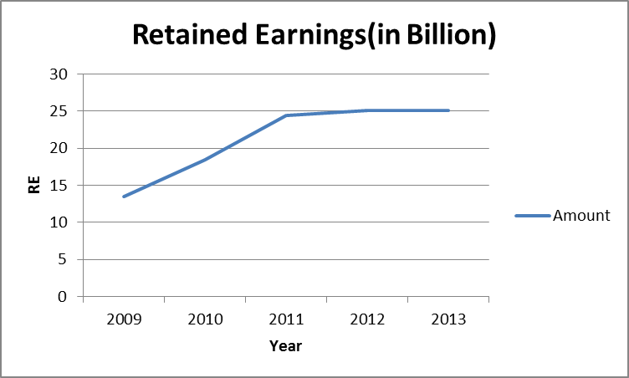 | 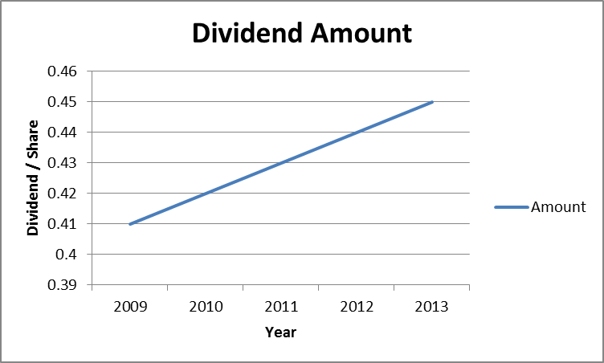
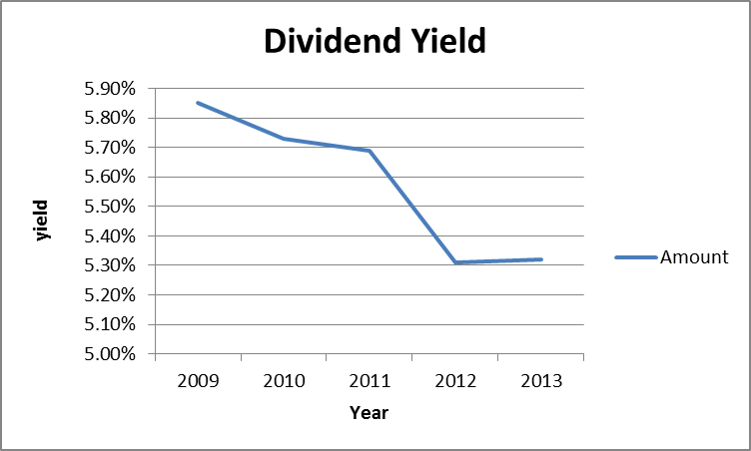 | 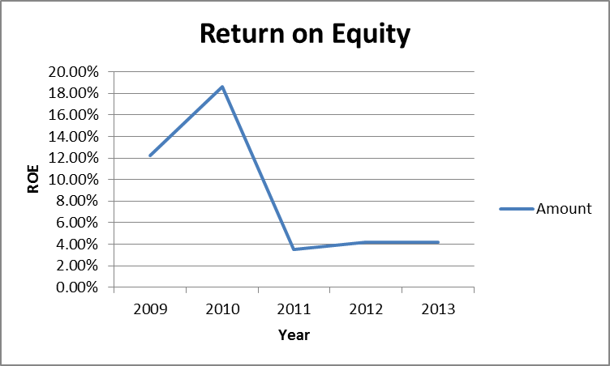
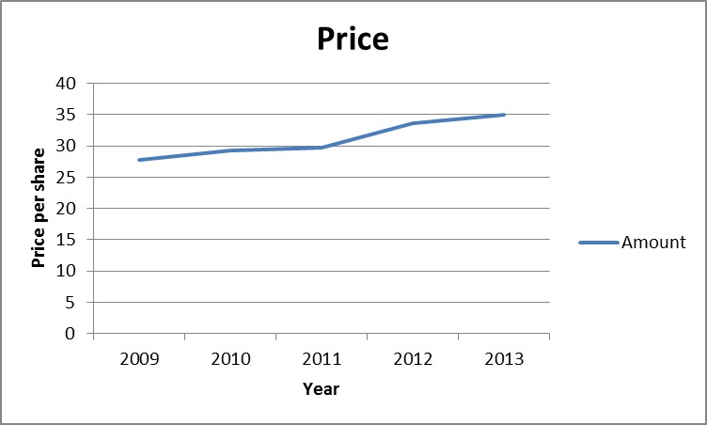 | 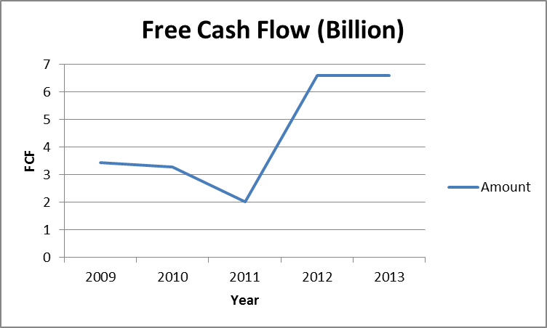

History of Stock Splits
The following table lists a history of AT&T stock splits.
Year | Split Information
1998 | March 19 — 2-for-1 common stock split
1993 | May 25 — 2-for-1 common stock split
1987 | May 22 — 3-for-1 common stock split
Expected Stock Price (sub-question 2):
Using the Dividend Discount Model, -
- P0 = $33.66
- D0 = $0.44
- R = Return on equity = 4.36%
- D1 = D0 * (1 + g)
- P0 = D1 / (r - g)
- g = 3.0%
- P1 = D0* (1 + g)(1 + g) / (r - g)
- Expected stock price = $34.66
AT&T’s stock’s estimated price at the end of 2nd quarter of year 2013 is $34.66
Future Assessment (sub-question 3):
Based on the stock history, it can be assessed that the present performance provides a positive future outlook for investors:
- 10% Increase in Earning Per Share: $0.66 compared to $0.60 diluted EPS in the year 2011
- 0.3% Increase in consolidated sales revenues of $31.6 billion
- Operating income margin of 30.3 percent
- $2.5 billion in stock buybacks; 75.8 million shares repurchased
- Huge Free cash flow of 6.608Billion
All the above numbers show a strong financial position and robust cash generation which is a good indicator in terms of the future growth prospects of the company. Improved revenue margin in the Wireless, its core business, gives investors and consumer confidence that company going stable and strong. Compared to Industry and S&P 500, AT&T is performing well.

 | Company | Industry | S&P 500
Valuation Ratio
P/E Ratio (TTM) | 43.80 | 17.50 | 17.70
Profitability Ratios (%)
Gross Margin (TTM) | 56.40 | 58.30 | 46.90
Gross Margin - 5 Yr Avg | 58.50 | 60.60 | 47.70
Dividends
Dividend Yield | 5.40 | 5.20 | 2.10
Dividend Yield - 5 Yr Avg | 5.30 | 4.80 | 2.20

